37.28: The force is found from Eq. (37.32) or Eq. (37.33). (a) Indistinguishable from 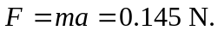 b) 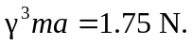 c) 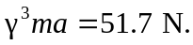 d) 